
Downtown South Bend, Inc. Exterior Enhancement Grant
2023 GUIDELINES

The Exterior Enhancement Grant through Downtown South Bend, Inc. (DTSB) is a competitive grant encouraging property/business owners to renovate or restore building facades and adjacent streetscapes in downtown South Bend for an overall improvement to the pedestrian landscape.

The grant is structured as a rebate program under which grant awardees are reimbursed 50% of the total amount spent on the qualifying portion of the project (minimum of $5,000 and maximum of $20,000).

Purpose
To partially fund well-designed building façade and streetscape improvements that respect the building’s history, original design integrity, and adjacent structures. By making a noticeable visual enhancement in the downtown area the common urban environment will be improved thus greatly impacting the overall effort to revitalize downtown.

A good example of the projects we seek is shown below:

BEFORE  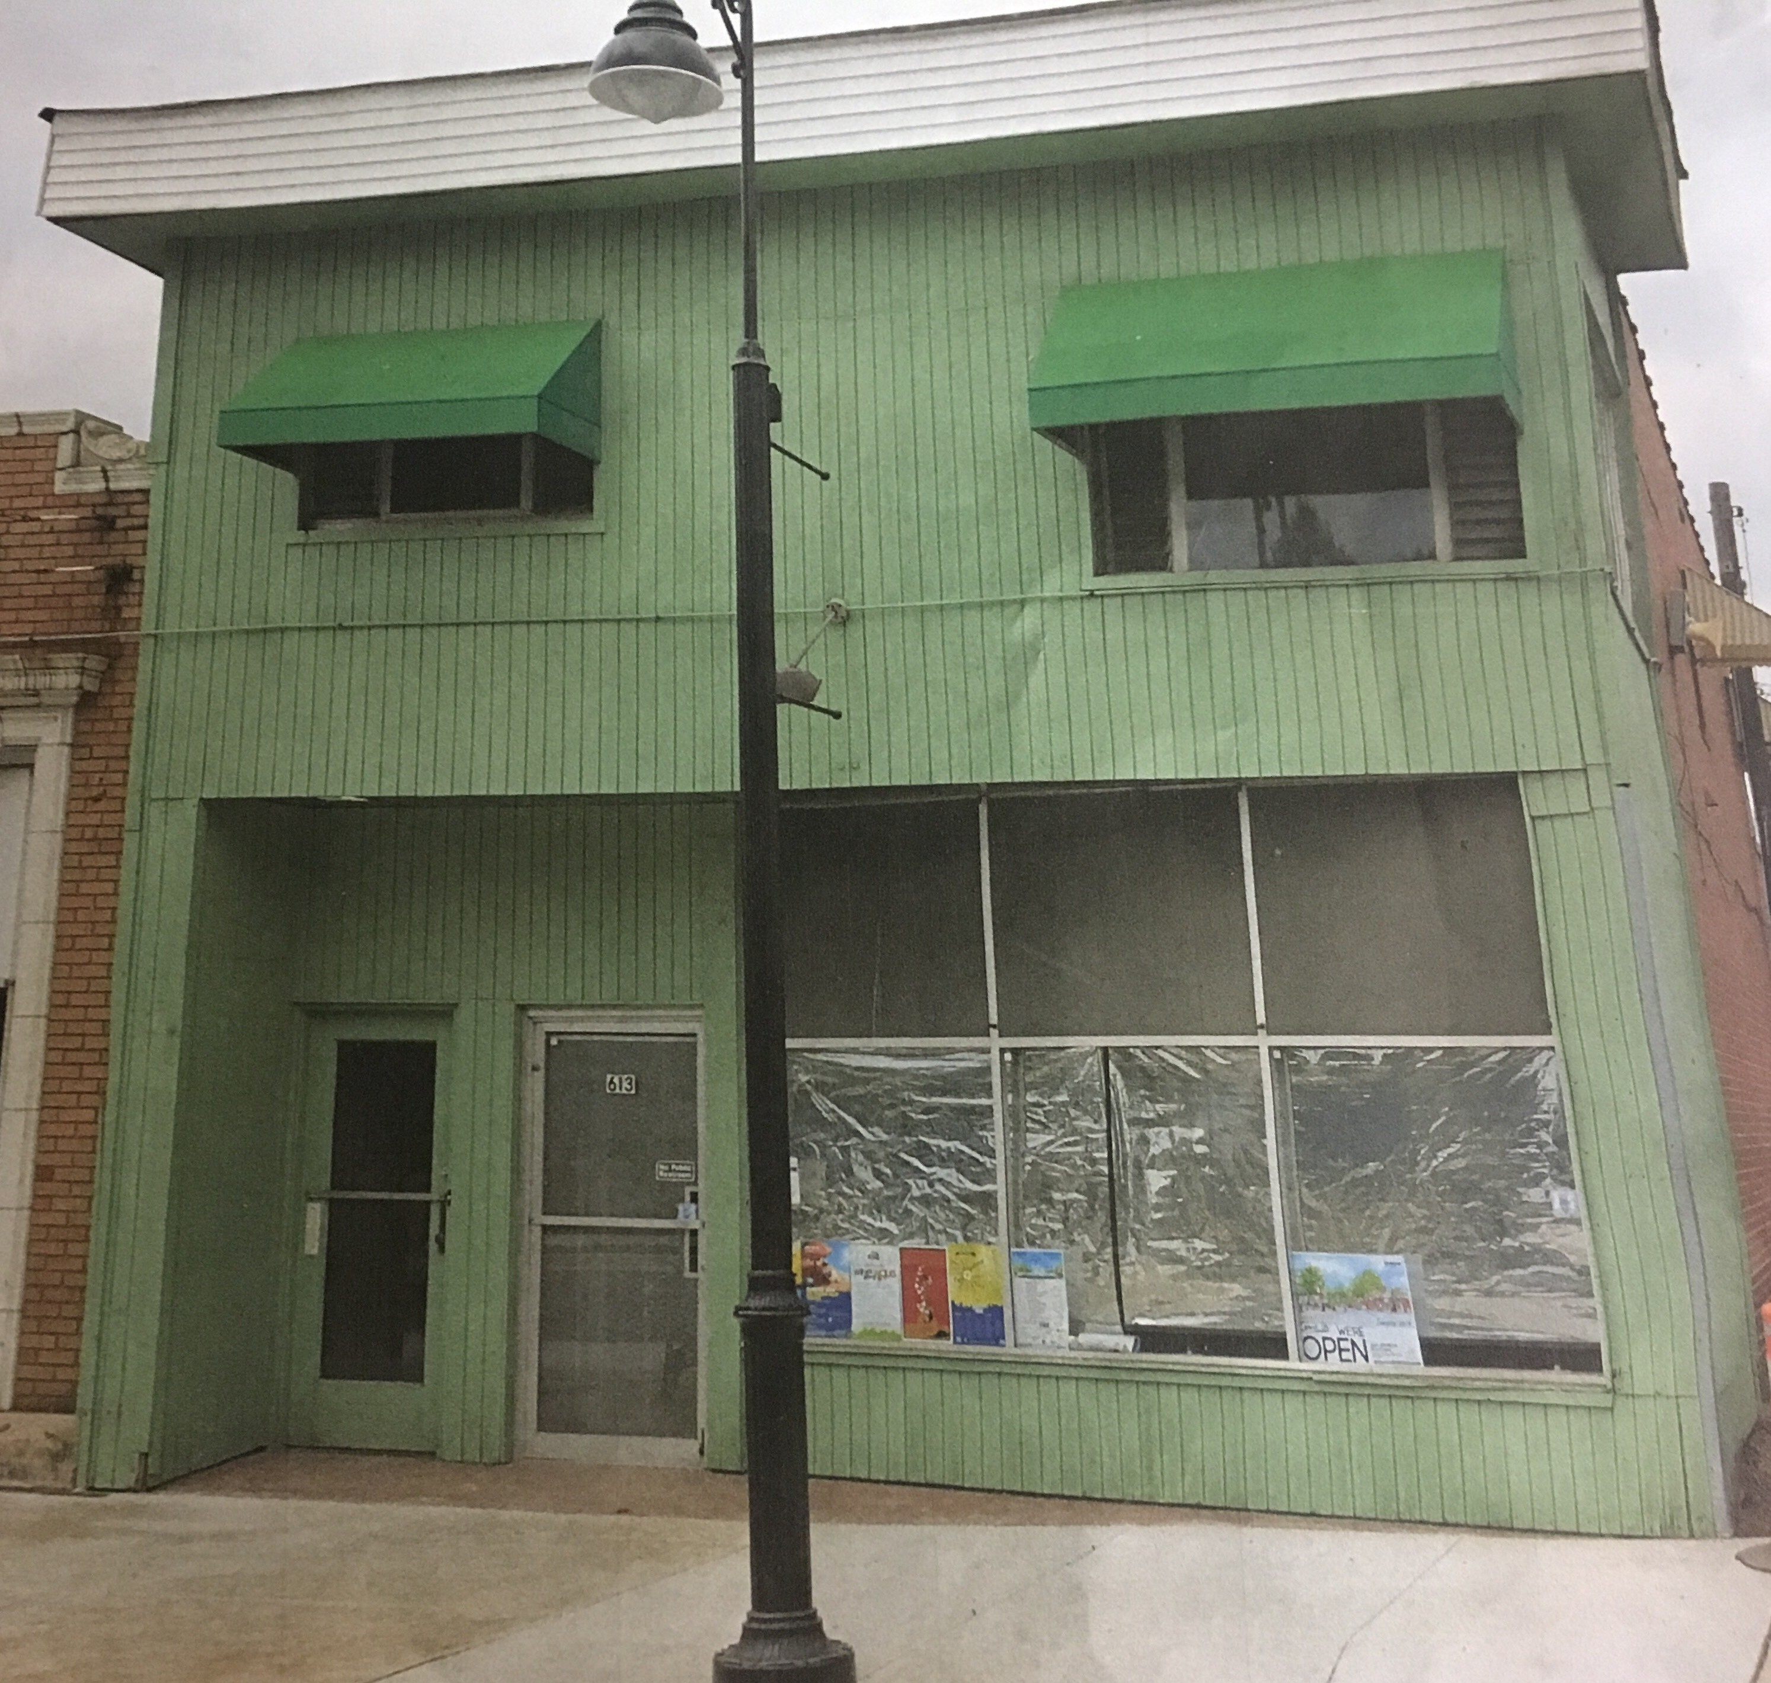 | AFTER  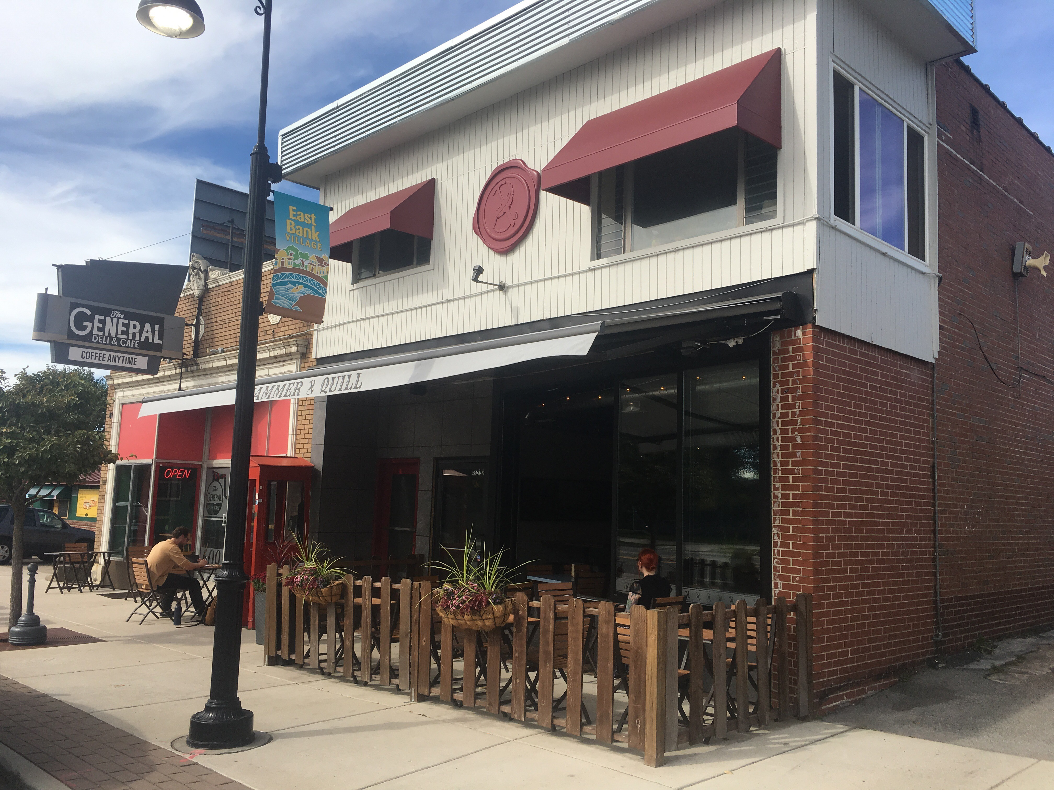
Note: Routine maintenance work such as painting and normal repairs are excluded from the grant.

2023 Theme - Vibrant Downtown
Preference will be given to projects that:
- Improve the public and pedestrian environment of downtown South Bend
- Improve the external appearance and lighting of storefronts in order to attract more customers and enhance the attractiveness of downtown South Bend
- Activate unique spaces and businesses to create one-of-a-kind experiences

Application Limitations
A downtown business is typically eligible for one grant per year. Prior façade grant recipients are eligible to apply for a new façade grant after a one-year waiting period from the date of award.

A. PROGRAM CRITERIA
- Grant Boundaries: Exterior Enhancement Grants will be awarded for significant improvements to property located within the area outlined on the map below. Significant improvements are defined as a major change that has a notable visual impact on the aesthetics of the downtown (normal repainting or repair work done due to wear and tear will not be covered; decisions as to whether a project is a significant change will be made by the Grant Committee.) Any properties located in a “hot spot” (highlighted red) will be given top consideration. Secondary consideration will be given to properties in Tier 2, then Tier 3.
Hot Spot
Hot Spot
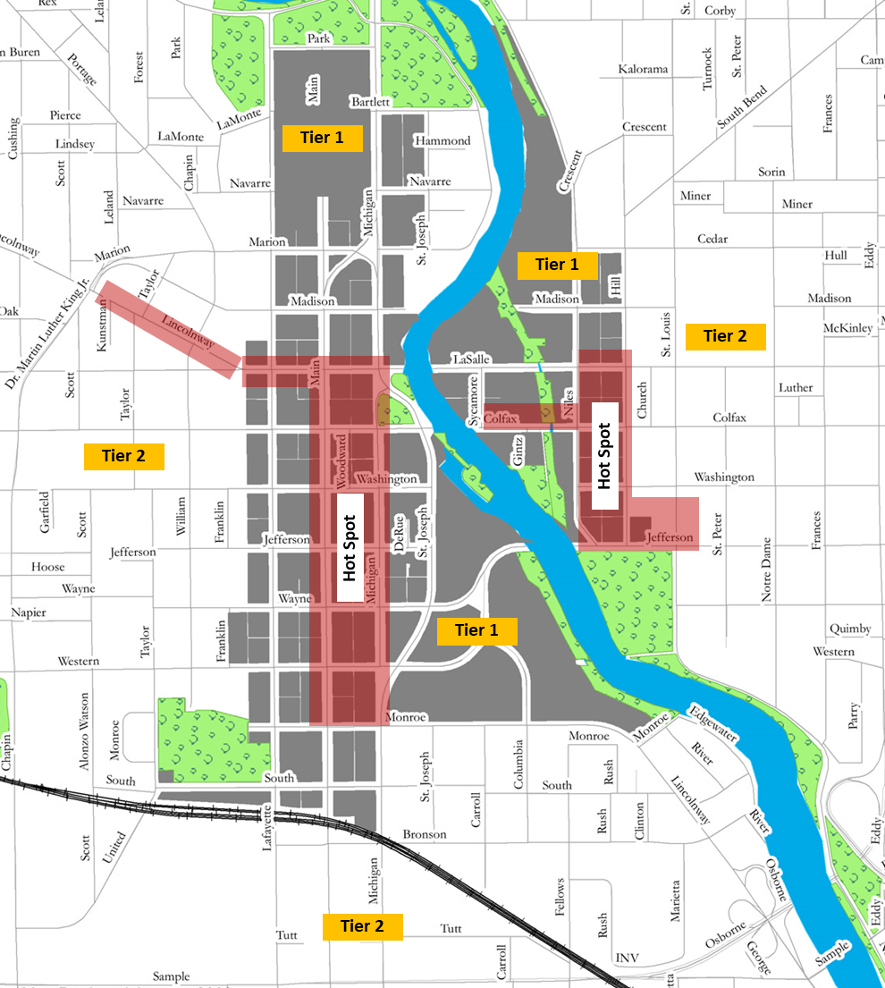

Tier 2
Tier 2
Tier 2
Tier 3
Tier 2
Tier 3
Tier 2

- Eligible Projects: Eligible projects must result in a visible improvement to the property and add vibrancy to the street. This program is not designed to fund general maintenance. The following types of improvements are eligible for funding on commercial spaces within the boundaries outlined above:
- Installation of commercial façade improvements appropriate to the architectural style, age and character of individual buildings
- Enhancements that activate the sidewalk such as outdoor dining areas, merchandise displays or planters
- Open storefronts and active rooftops that encourage interaction between the street and business
- Architectural lighting including: lighting which enhances the building’s façade and enhances the pedestrian environment, lighting of window display areas and lighting of architectural details
- New canopies or awnings that contribute to a well-designed and inviting storefront
- Unique signage that adds to the character of the streetscape.

Additional Notes:
- Front and side elevations of the same building will be considered one project.
- If your exterior activation idea includes use of public areas outside your “normal” operating footprint, the City of South Bend may be able to help qualify the use of the property.
- DTSB can also make available permanently installed trash receptacles, benches, and bike racks near or around your business. If you have an area that may be a good candidate for this type of street furniture, please let us know.

- Items excluded from Exterior Enhancement Grant qualifying expenditures
  - Routine maintenance (painting, cleaning, etc.)
  - Portable patio heaters, pop-up tents, furniture / fixtures
  - Consumer grade umbrellas
  - Rented items
  - Design & engineering fees

- Please download and review the “Vibrant Downtown Examples” PDF located at the bottom of the Exterior Enhancement Grant website for specific examples of the types of Exterior Enhancement Grant expenditures the committee will be giving preference to for this year’s theme.

- Other Building Exterior Improvements - secondary consideration
- Exterior painting that incorporates a major visual change (maintenance painting does not qualify)
- Significant masonry cleaning, and restoration modification (if part of an overall design restoration; general building maintenance repairs are not included)
- Addition of awnings (business logo & letters on awnings are acceptable)
- Enhanced exterior building lighting that creates a noticeably enhanced appearance (replacement of current lighting that is simply repair and does not enhance the appearance of the building, such as replacement of inoperable fixtures, is not included)
- Storefront entry systems and individual windows and door replacement or modification (if part of an overall design restoration; general building maintenance repairs are not included)
- New or restored façade elements such as: cornices, soffits, canopies, stringcourses, and other detail elements

- Eligible Streetscape expenditures
    - Streetscape plantings
    - Street furniture
    - New curb and sidewalk
    - Street lights
    - Related amenities

- Ineligible Uses: Grants may not be used for refinancing existing loans, working capital, inventory, permits, inspections, security fencing or gates, demolition of structures, roof repair or replacement, interior remodeling, and routine maintenance.

- Project Timeline: Projects need to have both a 2023 start date and a 2023 end date to be eligible for consideration.

- Compliance with Laws and Regulations: No grant under this program will be awarded to any party having a record of violations of laws or regulations, whether or not such violations are directly related to the property that is the subject of the grant application, that in the opinion of DTSB tends to show a consistent pattern. Depending on the scope of work, Building Permits or other approvals may be needed before the project begins. Failure to secure the appropriate approvals may affect grant payments.

- Licensed Contractors: All work must be done by licensed contractors. Applicants may call the City of South Bend Building Department at (574) 235-9554 to determine whether their contractors are licensed.

- Financial Responsibility: This is a rebate program. Accordingly:
  - Applications must include adequate evidence of financial ability to complete 100% of the proposed project (e.g. bank statement, bank letter, or loan commitment letter); and
  - The cost of all work must be paid in full by the applicant before any grant funds will be paid to the applicant by DTSB. The applicant shall provide proof that all costs have been paid in full if required by DTSB.

- Compliance with Design Guidelines: The project must comply with all design guidelines and streetscape product specifications in the City Ordinances, Zoning Ordinance, Building Codes, and Americans with Disabilities Act Guidelines and the General Design Enhancement Guidelines (Attachment A). Please download and review the “Zoning Guidelines” PDF at the bottom of the Exterior Enhancement Grant website for more details on the City of South Bend Zoning Ordinance.

- Compliance with City Ordinances: After completion of the project, the entire property must contain no violations of City Ordinances or Building Codes. Applicant must provide a photocopy of final sign-offs by all authorities having jurisdiction with the final application for the matching grant funds.

B. APPLICATION & GRANT PAYMENT PROCESS
FULL APPLICATION DEADLINE: 5:00 pm EST on Friday, March 31

The application can be delivered:
- Electronically by emailing Courtney Kubly at ckubly@downtownsouthbend.com
- By mail to the DTSB office at 217 S. Michigan Street, South Bend, IN 46601
- In person

For any further inquiries, please feel free to call Courtney at 574-968-7292 or email ckubly@downtownsouthbend.com

PROCESS:

- Submit the full application by the deadline of 5:00 pm on March 31
Each grant applicant must follow all grant application procedures, applicable design guidelines, and streetscape product specifications. The cost to prepare the application, if any, is the sole responsibility of the applicant.

- The Application is Reviewed
The Grant Committee will review the application and decide on the grant based on a set of criteria established by the committee (Attachment B). Depending on the nature of the project, the applicant and their architect/contractor may be asked to make a presentation to the committee.

- Applicant Notified of Decision
DTSB will notify grant applicants of their status after all applications have been reviewed and applicants have presented their proposals to the committee. The DTSB Grant Committee and the DTSB Board reserve the right to, in their sole discretion, limit participation in the grant program subject to available funding, location of the project, adherence to the Vibrant Downtown Theme, the positive impact of the improvements on the area and the streetscape, the level of financial participation by owner, or for any other reason.

- Start Construction and Complete Project by October 31, 2023
RECIPIENT shall complete PROJECT by October 31, 2023. Written notification must be made to DTSB along with a construction schedule for the work associated with the Grant if this timeline cannot be met. Failure to provide and / or begin the project in the scheduled amount of time without a formal request in writing and approval of an extension by DTSB will constitute a breach of the contract and funding will be withdrawn.

- Submit Grant Payment Request Letter with Proof of Payment and Project Completion by November 15, 2023
Once improvements are complete, (all authorities having jurisdiction have provided final certification of compliance) the applicant shall submit to DTSB - prior to November 15, 2023 - a grant payment request letter, accompanied by appropriate proof of expenses, proof that project was completed in-keeping with the scope of work originally approved by the committee, code compliance final review and approval, and proof of payments. At this time, you should also fill out a W-9 form from DTSB so we can send you a 1099 if applicable. This step is not required if you are incorporated.

- Grant Check Mailed within approximately 30 days of Receiving Final Waiver of Lien from Contractor
Grant monies will be paid at the completion of the project and once a copy of the contractor’s Final Waiver of Lien has been provided. Grant check will be mailed to recipient within 30 days after DTSB approves completed project.

Neither DTSB nor the City of South Bend shall have any liability for workmanship, design, or schedule delays related to the project receiving grant funds under this Program.

Any member of the DTSB Exterior Enhancement Grant Program Committee must notify the DTSB Staff Person of any association with any projects coming before the Committee for review or funding. Said members will recuse themselves in voting for the approval for any such projects.

